Introduction
This technical documentation page will be dedicated to version control system git. It will help guide a newbie to quickly set up and understand how to use git via command line terminal.
Simply put, a version control is a local or remote system that can track, record, and recall the life-cycle of a file or a series of files. Git generally only ‘adds’ data, but don’t be fooled you can accidentally lose sight of your data if you improperly handle commits, branches, etc.. Git uses a file system called a repository that tracks within the folder you initiate git to track (more on that later).

Git on the Downloads
Depending on your OS there are a few ways to download git, but first follow the directions from the mother ship’s download page:
Git download page
https://git-scm.com/downloads

Linux (Ubuntu/Debian)
First install: <span class=”text-danger”>install-info </span> package
$ sudo apt-get install install-info

Second install: install git
# apt-get install git

Git Setup
Customizing your git pathway will avoid hazardous confusion and random path errors.
1. <span class=”text-danger”> git config</span> is a powerful way to set up your user identity such as: user.name, user.email, colors, etc.
2. Choose a location on your hard drive where you want to store git configuration, after use this command:
$ [path] etc/gitconfig
For values specific personally to the user use this command instead:
~/.gitconfig or ~/.config/git/config

Your identity is how anyone knows who did what, but this also helps track your work, just in case you need to revert something back to a prior state.
$ git config --global user.name "James Jeremiah King"
$ git config --global user.email johndoe@example.com

Final step in git config is to checkout your settings:
git config --list --show-origin

Git With It
Although, data saved to git is not forever gone, but do be careful what you delete if you’re using github. Github does trash pickup every 30 days, which essentially does a hard delete of your trash content.
Here is an illustration on the The Three States of your files: modified, staged, and committed.
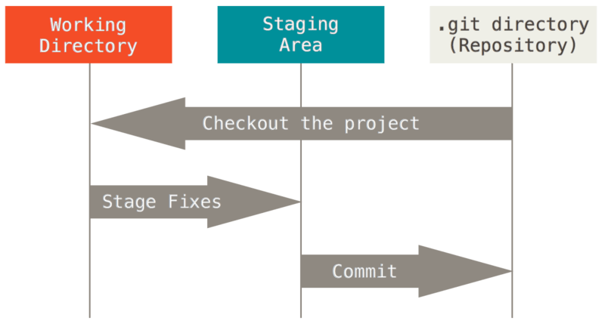
Now that you have a visual to work off we can use some terminology from here on out. When we commit to our repository it will be saved to the local repository until you request to pull to the master repository. Before we get too ahead of ourselves, lets set up our first repository or clone an existing repository on our local machine.

Git Initiated
The great thing about git is that it can be added to an existing directory or initialized to start a new project.
Linux:
$ cd home/user/my_project

You will notice in that .git directory that magically appeared, this is a new sub-directory that contains your essential git repository files.
Say there is an amazing project that you want to get involved in either for work, or to gain experience, than you must copy/clone an existing repository.
Copying or Cloning a public or private repository
$ git clone https://github.com/jking026/freeCodeCamp.git
To clone the repo with a name specify the name at the end with a space between.
$ git clone https://github.com/jking026/freeCodeCamp.git jkingFCCs

Git Committed
Congrats, if you made it this far, then you are truly committed to git, so what now?
When you are making changes, keep in mind that each file in your working directory can be in one of two states: tracked or untracked.
Tracked files are files that git knows about, while untracked are everything else mainly that are not in the staging area or the last snapshot.
To check the status of your branch and its content use this:
$ git status

With the git status command you can check which branch you are in, if your files are tracked/untracked , staged or unstaged.
When you want stage a modified file use this command:
$ git add <file name>
or to add all files
$ git add .

Once they are staged you must commit them to the head of the repository, but a message is mandatory, if you don’t add a message-git will automatically abort your commit.
$ git commit -m “blah blah blah”
It is highly recommended that you put some effort into your commit message. In fact, it shouldn’t be longer than 50 characters, but sometimes it cannot be helped than to add more. There is an etiquette to writing a git commit -m and for more info checkout out:
https://www.freecodecamp.org/news/writing-good-commit-messages-a-practical-guide/

Gitting Help (Pun Intended)
- Doing your homework is essential, especially on the current version of git. There is a vast amount git content out there and most are based on particular versions. The best way to “git help” is to update to the most current version.
- If you are finding yourself lost at anytime, refer to one of these terminal commands:
  - $ man git-log <verb>
  - $ git <verb> --help
  - $ man git-<verb>

or
  - $ git help log
these commands will be your knight in shining armor, but are never too sound.
[Tip-Time#1]- use a $ git command followed by –help and it will link you directly to the terminal commands manual page.
Example #1: [ $ git (command) - - help]
space after the command with 2 dashes is required.

Code: code box
<div class="listingblock">
<div class="content">
<pre>$ man git-log</pre>
</div>
</div>

Git Mas
There is never enough information on git and trying to reach out to millions of git users across the globe can be exciting and frustrating. The best source is the original source, and I urge you to read through Pro Git manual by Scott Chacon and Ben Straub (it’s FREE).
https://git-scm.com/book/en/v2
You can also checkout out YouTube videos, Udemy courses, Coursera, and so much more.

References
Thanks to all the vast information of the web, I was able to compile all of my information from these sources, please check them out!
Pro Git book: Scott Chacon and Ben Straub
https://git-scm.com/book/en/v2

Atlassian: Learn Git with Bitbucket Cloud
https://www.atlassian.com/git/tutorials/learn-git-with-bitbucket-cloud

Axosoft- learning Git: What is a Git Repository? By Jonathan Silva
https://blog.axosoft.com/learning-git-repository/

